create database Assessment

use Assessment

create table Subject(subjectId int, subtitle varchar(20))

select * from Subject

create table Book(bookId int,

title varchar(20),

price int,

volume int,

author varchar(20),

publishDate Date,

subjectId int

)

select * from Book

--1. Insert 5 diff subjects in subject table

insert into Subject values(1,'English'),

(2,'Hindi'),

(3,'Malayalam'),

(4,'IT'),

(5,'Maths')

--2. Insert 15 diff books of 5 subjects in books table

insert into Book values(100,'Abc',100,1,'abc','12.01.2023',5),

(101,'Abc',100,1,'abc','12.01.2023',1),

(102,'Bcd',199,1,'bcd','06.02.2024',1),

(103,'Cde',299,3,'cde','07.08.2021',1),

(104,'Def',200,1,'def','12.01.2023',2),

(105,'Efg',300,1,'efg','03.02.2022',2),

(106,'Fgh',400,1,'fgh','12.01.2021',2),

(107,'Ghi',150,2,'ghi','12.01.1998',3),

(108,'Hij',190,1,'hij','12.01.2000',3),

(109,'Ijk',200,1,'ijk','12.01.2021',3),

(110,'Jkl',230,2,'jkl','04.05.1999',4),

(111,'Klm',450,1,'klm','12.01.2023',4),

(112,'Lmn',320,1,'lmn','12.01.2000',4),

(113,'Mno',500,3,'mno','04.08.1999',5),

(114,'Nop',590,1,'nop','02.01.2023',5)

--3. Write a query to retrieve the book and its subject details using inner join.

select s.subjectId,s.subtitle,b.bookId,b.title,b.price,b.volume,b.author,b.publishDate from Subject s join Book b on s.subjectId=b.subjectId

--4. Write a query to retrieve the books list published in a given specific date interval

select * from Book where publishDate between '04.08.1999' And '12.01.2021'

--5. Write a query to retrieve the number of books referred by each author

select author, COUNT(*) AS bookCount FROM Book GROUP BY author;

--6. Write a query to retrieve the number of books referred by each subject

select subjectId,COUNT(*) as 'Books Count' from Book group by subjectId

--7. Write a query to retrieve the number of books published by the year 2000

select count(*) as 'Books by Year' from Book where YEAR(publishDate)=2000

--8. Write a query to update price and volume of a book using bookId.

update Book set price=499, volume=2 where bookId=106

--9. Write a query to update price of English subject books 10%

update Book SET price = price * 1.1 WHERE subjectId=(select subjectId from Subject where subtitle='English')

--10. Write a query to delete a book using bookId

delete from Book where bookId=100

--11. Write a query to retrieve books who’s price is >500 and subject is maths.

select * from Book where price>500 and subjectId=(select subjectId from Subject where subtitle='Maths')

--12. Write a query to retrieve the book and its subject details with ascending order of subject.

select s.subjectId,s.subtitle,b.bookId,b.title,b.price,b.volume,b.author,b.publishDate from Subject s join Book b on s.subjectId=b.subjectId order by s.subtitle

--13. Write a query to retrieve the min price of book details.

select * from Book where price=(select MIN(price) from Book)

--14. Write a query to retrieve the max price of the book details

select * from Book where price=(select max(price) from Book)

--15. Write a query to count the no of books of subject maths.

select COUNT(subjectId) as Count from Book where subjectId=(select subjectId from Subject where subtitle='Maths')

--16. Write a query to display books of subject english, maths and IT.

select * from Book where subjectId in (select subjectId from Subject where subtitle In ('English','Maths','IT'))

select s.subjectId,s.subtitle,b.bookId,b.title,b.price,b.volume,b.author,b.publishDate from Subject s join Book b on s.subjectId=b.subjectId where subtitle in('English','Maths','IT')

**Output:**

Qn3

Qn4

Qn5

Qn6

Qn7

Qn11

Qn12

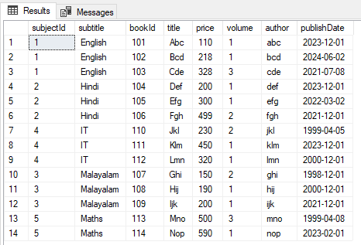

Qn13

Qn14

Qn15

Qn16

